STARTUPJET WEBSITE ERROR
- For creation of logo: Command option should be specified.
{NOT IMPLEMENTED} - logo options clearly defined
- Trademark availability search
- Classes of goods/services not working/selecting {IS A LIST INSTEAD OF DROPDOWN} {NOT FIXED}
- Search Filter
- The search filter option needs to be implemented.
{NOT IMPLMENTED}
- Tags
- Tags are not clickable.
{NOT FIXED}
- Booking Cancellation
A booking cancellation and refund option is required.
{NOT IMPLMENTED}
- Services
  - A "Cancel Option" is needed for services.
{NOT IMPLMENTED}
- Post-Payment Editing
  - After payment, provide an option for users to edit their submission details for a limited period of time.
{NOT IMPLMENTED}
- Miss alignment on mobile screen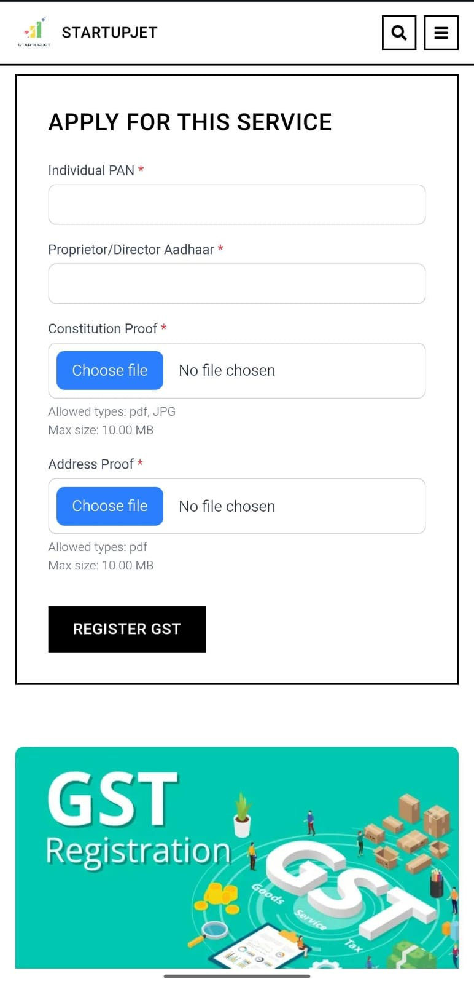

FEATURE REQUESTS:
- Different implementation for NRI? Or a NRI help/contact option, for NRIs to use because many forms have different requirements if you are an NRI also a separate NRI FAQ panel or page.
Navigation Highlight issue
- After clicking the ‘Final Experts ‘ button the page opens but there is no back navigation. Option to return to the previous page.
- After opening any AI Tool dropdown (AI Logo Generator, Business Idea Analyzer,AI Legal Documents), there is no back or navigation option to return to the main AI Tools page.
- We should add footer section

